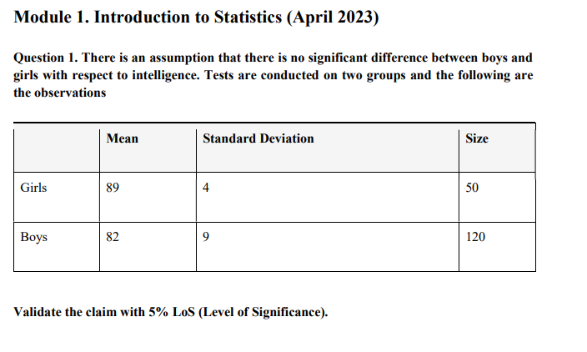

89-82=7

4²/50+9²/50 (square root) =

7/ 1.3928

**t value = 5.0258**

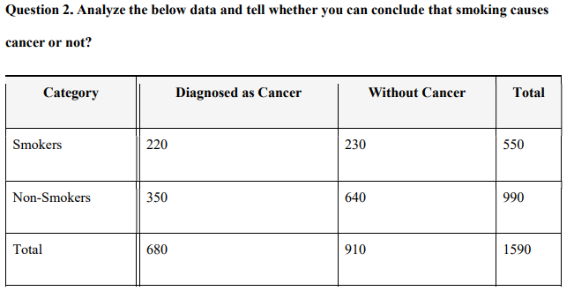

**Ans :**

**Row total* column total / overall 550*990/1590 = 342.4528**